MODERNIZATION OF THE SCIENCE LAB

Emphasizing on practical learning, the Kendriya Vidyalaya Sangathan (KVS) has decided to modernise the science and mathematics laboratories in its schools KVS has also planned to set up language laboratories to promote vernacular studies. At the same time, it also wishes to introduce French and Chinese language in schools from this year.
As per the initiative by NITI AYOG led By Honourable Prime Minister Shri. Narendra Modi modernisation of the school laboratories is one of the major activities of the Sangathan
The National Council of Educational, Research and Training, CBSE and other agencies will provide advanced kits to the labs of the schools. The labs will also have internet connectivity to facilitate students with an access to online laboratories. The main purpose behind upgrading the laboratories is to make practical learning more interesting and contemporary.
1 | Electronic Plug-in Kit | 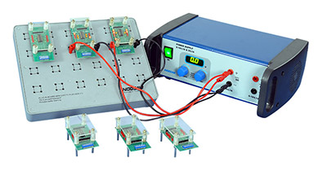
2 | Franck Hertz Experiment | 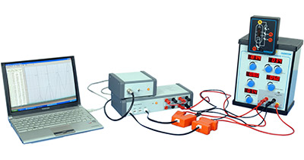
3 | Colour Mixer | 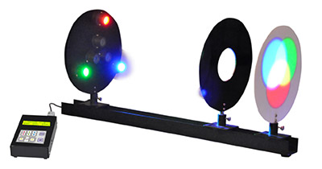
4 | Field Lines and Equipotential Lines | 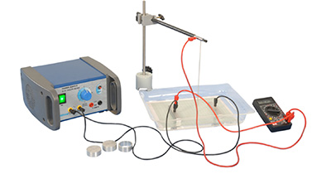
5 | Linear Air Track with Digital Timer | 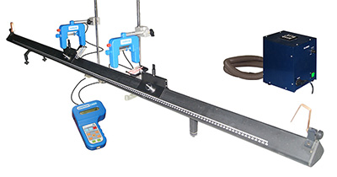
6. | Compact Wave Tank | 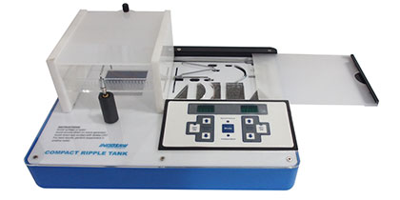
7 | Electrostatic | 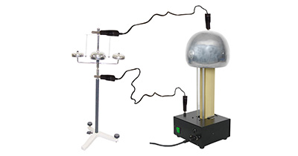
8. | Electricity | 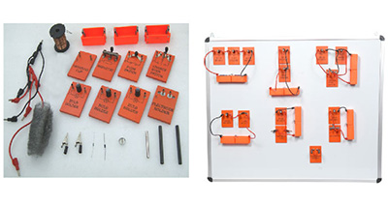
9. | Electromagnetism | 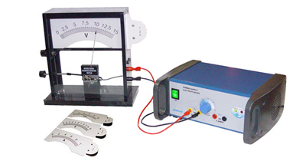
10. | Science with Datalogging | 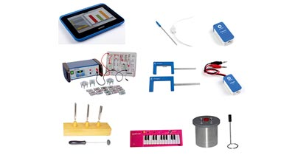
11 | Chemistry | 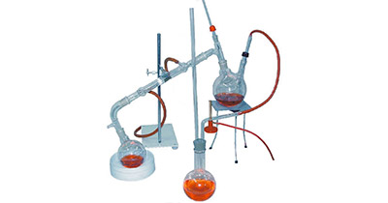
12. | Biology | 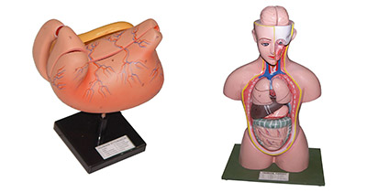
13 | Mechanics | 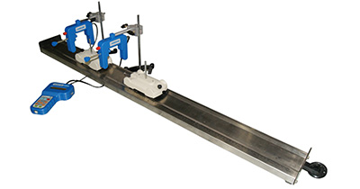
14 | Light & Optics | 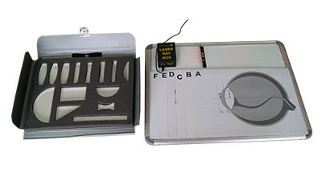
15. | Heat | 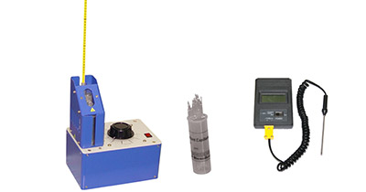
16. | Waves | 