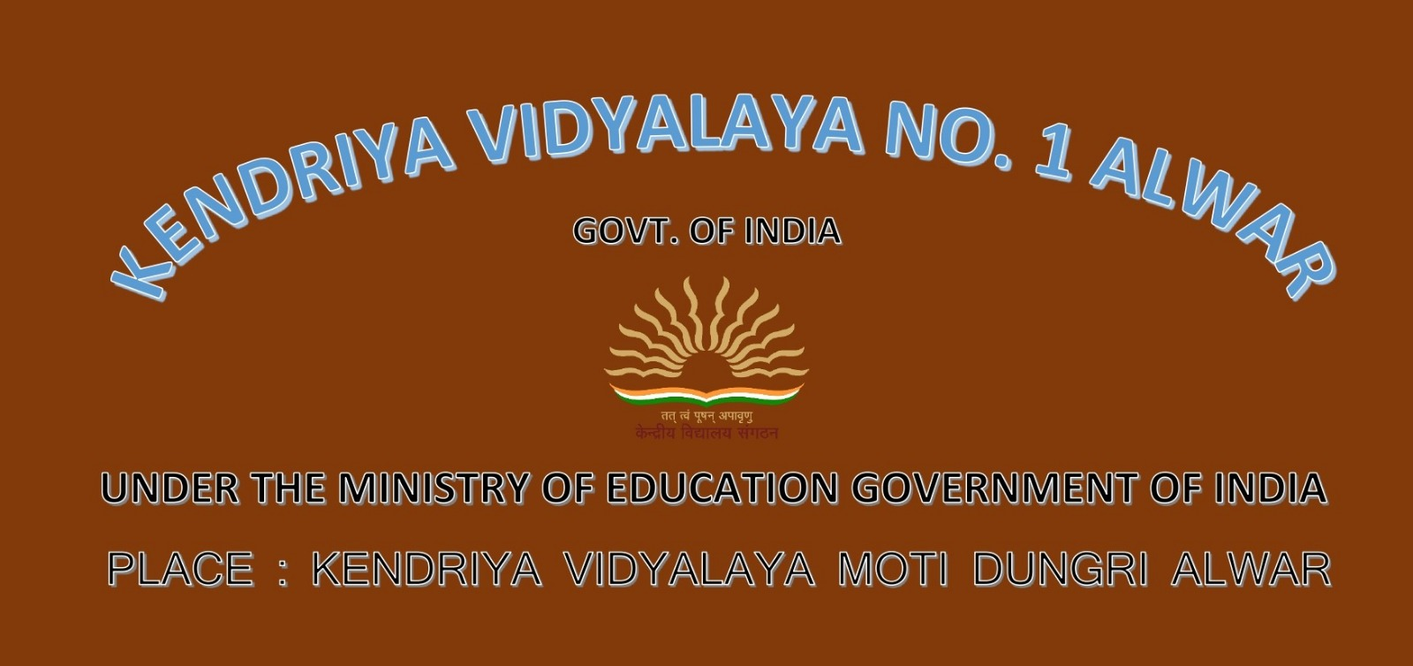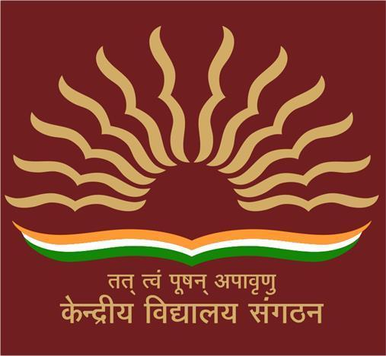**ANNUAL ACADEMIC CALENDAR 2023-24**

|  |  |  |  |  |  |  |
| --- | --- | --- | --- | --- | --- | --- |
| **APRIL 2023** | | | | | | |
| **SUN** | **MON** | **TUE** | **WED** | **THU** | **FRI** | **SAT** |
| **26** | **27** | **28** | **29** | **30** | **31** | **1** |
| **2** | **3** | **4**  **Mahavir Jayanti** | **5** | **6** | **7**  **Good Friday** | **8** |
| **9** | **10** | **11** | **12** | **13** | **14**  **Ambedker jayanti** | **15** |
| **16** | **17** | **18** | **19** | **20** | **21** | **22**  **RAMJAN ID-UL-FITAR** |
| **23** | **24** | **25** | **26** | **27** | **28** | **29** |
| **30** | **1** | **2** | **3** | **4** | **5** | **6** |

**Activities:**

**Apr 7** Good Friday

**Apr 14** Ambedker jayanti

**Apr 22** Ramjan

1. Setting of Academic Target, Mission Statement of KV & Display Learning Outcomes
2. Bridge Course for slow achievers
3. Pustkouphaar
4. Tarunoutsav of Class X appeared students
5. Distribution of Student Diary, ID cards
6. 1st NIPUN Meeting
7. Notification of Various Committees at Vidyalaya level as per directions of KVS
8. Conduct of Supplementary Examination.
9. Sharing the Assessment Scheme to students, teachers and parents for the Academic Year 2023-24
10. Rashtriya Bal Vaigyanik Pradarshani – Regional Level
11. Atal Tinkering Labs (ATL) activities (To be continued in all the Months)
12. School level competition on Vocal & Classical Music of paired state
13. Vidyalaya Level Sports Competition
14. State Level President (S/G) Certificate Examination Testing Camp
15. Discussions/Speech by Principal, Teachers & Students in Morning Assembly to make children aware about history of school and achievements of school
16. Dr. Bhim Rao Ambedkar Jayanti 14th April
17. World Health Day 7th April

|  |  |
| --- | --- |
| **Activities:** | |
| **May 05** | Budhha Purnima |
| **May 07** | **RAVINDRA NATH TAGORE JAYANTI** |
| 1. Art Integrated Project to students 2. Assignment of Holiday Homework in multidisciplinary project. 3. Vidya Pravesh for Class-I 4. Review of Class IX & XI results 2022-23 after supplementary examination and Plan of 5. Action for better results in the session 2023- 24. 6. CSIR Lab Visit under JIGYASA 7. Collection and exhibition of Millets of partner state (IYM) 8. Mental Health Assessment Battery Test for identification of Good Players 9. Weekly Troop/Company/Pack/ Flock/ Meeting at Vidyalaya Level 10. Sensitization to Students, Teachers and Parents on Mission LiFE (Life Style for Environment) 11. Children Book Week 2nd to 8th May. | |

|  |  |  |  |  |  |  |
| --- | --- | --- | --- | --- | --- | --- |
| **MAY 2023** | | | | | | |
| **SUN** | **MON** | **TUE** | **WED** | **THU** | **FRI** | **SAT** |
| **30** | **1** | **2** | **3** | **4** | **5**  **BUDHHA PURNIMA** | **6** |
| **7**  **RAVINDRA NATH TAGORE JAYANTI** | **8** | **9** | **10** | **11** | **12** | **13** |
| **14**  **Mother's day** | **15** | **16** | **17** | **18** | **19** | **20** |
| **21** | **22** | **23** | **24** | **25** | **26** | **27** |
| **28** | **29** | **30** | **31** | **1** | **2** | **3** |

|  |  |  |
| --- | --- | --- |
| **Activities:** |  |  |
| |  |  | | --- | --- | | **June 21** | World yoga day | | **June 29** | Bakri ID/Eid ul-Adha | |  |  |
| 1. Vidya Pravesh for Class I Students 2. Vidya Pravesh for Class I Students Correction of Summer Vacation Homework 3. CSIR Lab Visit under JIGYASA. 4. Classical and Folk Dance of Paired State. 5. Vidyalaya Level Sports Competition 6. Weekly Troop/Company/Pack/ Flock/ Meeting at Vidyalaya Level. 7. Conduct of lectures, Seminars, Expert Talk on Yoga & Mediation in KVs 8. How to eliminate Single Use Plastic - campaign both inside and outside of the school and use social medial handles to create awareness. 9. Celebration of International Yoga Day. 10. World Environment Day |  |  |
|  |  |  |

|  |  |  |  |  |  |  |
| --- | --- | --- | --- | --- | --- | --- |
| **JUNE 2023** | | | | | | |
| **SUN** | **MON** | **TUE** | **WED** | **THU** | **FRI** | **SAT** |
| **28** | **29** | **30** | **31** | **1** | **2** | **3** |
| **4** | **5** | **6** | **7** | **8** | **9** | **10** |
| **11** | **12** | **13** | **14** | **15** | **16** | **17** |
| **18** | **19** | **20** | **21**  **World yoga day** | **22** | **23** | **24** |
| **25** | **26** | **27** | **28** | **29**  **Bakri Id / Eid ul-Adha** | **30** | **1** |

|  |  |
| --- | --- |
| **Activities:** | |
| **Jul 3** | Guru purnima |
| **Jul 29** | Muharram |
| 1. Publication of Vidyalaya Patrika. 2. Vidya Pravesh for Class - I Students 3. Formation of Student Council by KVsAdmission of class XI. 4. Periodic Test-I for class III to X 5. Monthly Test for Class XII. 6. Registration for INSPIRE Awards MANAK Scheme (Tentative) 7. IOQM. 8. Writing of 100 sentences learnt in the language of paired state 9. Vidyalaya Level Sports Competition, 10. Self Defence Training/workshop for Girls class VI to XII. 11. Rajya Puraskar Testing Camp of Scouts and Guides 12. Compose Poem, Stories, Articles etc. on Azadi Ka Amrit Mahotsav 13. Van Mahotsav — Target ‘One Child One Plant’ | |

|  |  |  |  |  |  |  |
| --- | --- | --- | --- | --- | --- | --- |
| **JULY 2023** | | | | | | |
| **SUN** | **MON** | **TUE** | **WED** | **THU** | **FRI** | **SAT** |
| **25** | **26** | **27** | **28** | **29** | **30** | **1** |
| **2** | **3**  **GURU PURNIMA** | **4** | **5** | **6** | **7** | **8** |
| **9** | **10** | **11** | **12** | **13** | **14** | **15** |
| **16** | **17** | **18** | **19** | **20** | **21** | **22** |
| **23** | **24** | **25** | **26** | **27** | **28** | **29**  Muharram |
| **30** | **31** | **1** | **2** | **3** | **4** | **5** |

|  |  |
| --- | --- |
| **Activities:** |  |
| **Aug 30** | Raksha Bandhan |
| **Aug 15** | Independence Day |
| 1. 2nd NIPUN Meeting 2. CBSE LOC submission for Class X and XII (Tentative). 3. Monthly Test for Class X and XII.PTM, 4. School level selection of Project for NCSC. 5. Review of activities under STEM. 6. Cultural Competition- Folk dance/ patriotic song & music of the Paired state for classes I-XII 7. Celebration of National Sports Day 8. Regional Level Sports Meet. 9. Tritiya Sopan/Tritiya Charan/Sawarn Pankh Testing Camp. 10. Tritiya Sopan/Tritiya Charan/Sawarn Pankh Testing Camp. 11. Youth Parliament at Regional Level. 12. Celebration of Independence Day | |

|  |  |  |  |  |  |  |
| --- | --- | --- | --- | --- | --- | --- |
| **AUGUST 2023** | | | | | | |
| **SUN** | **MON** | **TUE** | **WED** | **THU** | **FRI** | **SAT** |
| **30** | **31** | **1** | **2** | **3** | **4** | **5** |
| **6** | **7** | **8** | **9** | **10** | **11** | **12** |
| **13** | **14** | **15**  **Independence day** | **16** | **17** | **18** | **19** |
| **20** | **21** | **22** | **23** | **24** | **25** | **26** |
| **27** | **28** | **29** | **30**  **Raksha bandhan** | **31** | **1** | **2** |

|  |
| --- |
| **Activities:** |
| **Aug 7 Janmashtami**  **Aug 19 Ganesh Chaturthi**  **Aug 28 Milad-Un-Nabi**  **Aug 29 Onam**   1. 1.Submission of Staff Sanction proposals for Academic Session 2024-25 2. Review of Action Taken of Academic Supervision & Plan of Action thereof. 3. Half Yearly Examination for Class III-VIII 4. Periodic Test –II for Class –IX & X 5. Periodic Test –I for Class –XI 6. Monthly Test for class XII 7. Verification of LOC for Class X and XII (Tentative) 8. Online CBSE Registration of Class IX & XI (Tentative) 9. Submission of Projects in INSPIRE Awards MANAK (Tentative) 10. Video Conferencing with students of Paired State for classes VI-XII. 11. KVS National Sports Meet for Boys & Girls 12. Participation in National School Games Khelo India. 13. Golden Arrow Award Camp of Cub/ Bulbul at Regional Level 14. Celebration of Teachers’ Day. 15. Hindi Diwas & Hindi Pakhawada. | |  |
|  |  | | |
| **Aug 15** | Independence Day | | |
| **Aug 19** | Janmashtami | | |
| **Aug 19** | Janmashtami | | |

|  |  |  |  |  |  |  |
| --- | --- | --- | --- | --- | --- | --- |
| **SEPTEMBER 2023** | | | | | | |
| **SUN** | **MON** | **TUE** | **WED** | **THU** | **FRI** | **SAT** |
| **27** | **28** | **29** | **30** | **31** | **1** | **2** |
| **3** | **4** | **5** | **6** | **7**  **Janmashtami** | **8** | **9** |
| **10** | **11** | **12** | **13** | **14** | **15** | **16** |
| **17** | **18** | **19**  **Ganesh Chaturthi** | **20** | **21** | **22** | **23** |
| **24** | **25** | **26** | **27** | **28**  **Milad-un-Nabi** | **29**  **Onam** | **30** |

|  |  |
| --- | --- |
| **Activities:** | |
| **Oct 02** | Mahatma Gandhi Jayanti |
| **Oct 24** | Dussehra / Dasara |

1. Distribution of Students Support Material for the Class X & XII students at Regional Level.
2. 1st Pre- Board Examination for Class X and XII (Winter Stations KVs)
3. Conduct of National Children Science Congress at KVs/ ROs & National Level
4. Celebrations of National Unity Day to commemorate the Birth Anniversary of Sardar Vallabhbhai Patel.
5. KVS National Level Competition on EBSB
6. KVS National Sports Meet for Boys & Girls
7. Participation in National School Games Khelo India
8. Seema Darshan (after Examination)
9. Investiture Ceremony at unit level
10. Celebration of Gandhi Jayanti
11. Vigilance Awareness Week

|  |  |  |  |  |  |  |
| --- | --- | --- | --- | --- | --- | --- |
| **OCTOBER 2023** | | | | | | |
| **SUN** | **MON** | **TUE** | **WED** | **THU** | **FRI** | **SAT** |
| **1** | **2**  **Mahatma Gandhi jayanti** | **3** | **4** | **5** | **6** | **7** |
| **8** | **9** | **10** | **11** | **12** | **13** | **14** |
| **15** | **16** | **17** | **18** | **19** | **20** | **21** |
| **22** | **23** | **24**  **Dussehra/ dasara** | **25** | **26** | **27** | **28** |
| **29** | **30** | **31** | **1** | **2** | **3** | **4** |

|  |  |
| --- | --- |
| **Activities:** | |
| **Nov 12**  **Nov 13**  **Nov 15**  **Nov 27** | Diwali/Deepawali  Govardhan pooja  Bhai dooj  Guru Nanak's Birthday |
|  |  |

1. Review of Subject Committee Meetings at School Level & Action Taken thereof.
2. 3rd NIPUN Meeting
3. Half Yearly Examination for Class XI.
4. Ist Pre- Board Examination for class X & XII (Summer Station KVs)
5. National Children Science Congress (NCSC) at KVS Level.
6. Speech/Debate/Essay/Quiz on Fundamental Rights & Duties/ Preamble of Constitution of India & Panchayat Raj System
7. Sports Day Celebration Participation in National School Games
8. Khelo India Tournament through States
9. Celebration of Bharat Scouts & Guides Foundation Day
10. Youth Parliament at Zonal Level
11. Celebration of Children’s Day
12. Celebration of Constitution Day

|  |  |  |  |  |  |  |
| --- | --- | --- | --- | --- | --- | --- |
| **NOVEMBER 2023** | | | | | | |
| **SUN** | **MON** | **TUE** | **WED** | **THU** | **FRI** | **SAT** |
| **29** | **30** | **31** | **1** | **2** | **3** | **4** |
| **5** | **6** | **7** | **8** | **9** | **10** | **11** |
| **12**  **Diwali/**  **Deepawali** | **13**  **Govardhan pooja** | **14** | **15**  **Bhai dooj** | **16** | **17** | **18** |
| **19** | **20** | **21** | **22** | **23** | **24** | **25** |
| **26**  **Constitution day** | **27**  **Guru nanak jayanti** | **28** | **29** | **30** | **1** | **2** |

|  |  |  |  |  |  |  |
| --- | --- | --- | --- | --- | --- | --- |
| **DECEMBER 2023** | | | | | | |
| **SUN** | **MON** | **TUE** | **WED** | **THU** | **FRI** | **SAT** |
| **26** | **27** | **28** | **29** | **30** | **1** | **2** |
| **3** | **4** | **5** | **6** | **7** | **8** | **9** |
| **10** | **11** | **12** | **13** | **14** | **15** | **16** |
| **17** | **18** | **19** | **20** | **21** | **22** | **23** |
| **24** | **25**  **Christmas** | **26** | **27** | **28** | **29** | **30** |
| **31** | **1** | **2** | **3** | **4** | **5** | **6** |

|  |  |
| --- | --- |
| **Activities:** | |
| **Dec 25** | Christmas |
| 1. Strategy for focused Revision and follow up after of Pre-Board Examination. 2. Special Classes for Class- X & XII 3. Pre-Board – II for Class X and XII 4. INSPIRE Awards MANAK - National Level (as per schedule notified by Department of Science Technology) 5. Student Exchange Programme with Paired State. 6. Participation in National School Games & Khelo India tournament through states 7. Seema Darshan (Winter Break) 8. Diwitiya Sopan/Dwitiya Charan/ Rajat Pankh Testing Camp 9. Annual Day Celebration 10. KVS Foundation Day (Diamond Jubilee Year) 11. National Mathematics Day | |

|  |  |
| --- | --- |
| **Activities:** | |
| **Jan 15**  **Jan 15** | Lohri  Makar Sankranti / Pongal |
| **Jan 17** | Guru Govind Singh jayanti |
| |  |  | | --- | --- | | **Jan 26** | Republic Day |  1. 4th NIPUN Meeting 2. Preparation for Class X and XII Board Examination. 3. Periodic Test – III for Class IX 4. Periodic Test –II for Class –III to VIII and Class XI 5. Internal Assessment, Project & Practical for Class IX & XII 6. Preparation of Art Project for School level Internal Assessment for 2023 Exam on partner state. 7. Medical Health Checkup 8. Weekly Troop/Company/Pack/ Flock Meeting at Vidyalaya Level 9. Celebration of Republic Day 10. National Youth Day | |  |

|  |  |  |  |  |  |  |
| --- | --- | --- | --- | --- | --- | --- |
| **JANUARY 2024** | | | | | | |
| **SUN** | **MON** | **TUE** | **WED** | **THU** | **FRI** | **SAT** |
| **31** | **1** | **2** | **3** | **4** | **5** | **6** |
| **7** | **8** | **9** | **10** | **11** | **12** | **13** |
| **14**  **lohri** | **15**  Makar Sankranti / Pongal | **16** | **17**  **Guru Govind**  **Singh Jayanti** | **18** | **19** | **20** |
| **21** | **22** | **23** | **24** | **25** | **26**  **Republic day** | **27** |
| **28** | **29** | **30** | **31** | **1** | **2** | **3** |

|  |  |  |  |  |  |  |
| --- | --- | --- | --- | --- | --- | --- |
| **FEBRUARY 2024** | | | | | | |
| **SUN** | **MON** | **TUE** | **WED** | **THU** | **FRI** | **SAT** |
| **28** | **29** | **30** | **31** | **1** | **2** | **3** |
| **4** | **5** | **6** | **7** | **8** | **9** | **10** |
| **11** | **12** | **13** | **14**  **Vasant Panchami** | **15** | **16** | **17** |
| **18** | **19**  **Shivaji Jayanti** | **20** | **21** | **22** | **23** | **24**  **Guru Ravidas Jayanti** |
| **25** | **26** | **27** | **28** | **29** | **1** | **2** |

|  |  |  |
| --- | --- | --- |
| **Feb 14** |  | Vasant panchami |
| **Feb 19** |  | Shivaji jayanti |
| **Feb 24** |  | Guru Ravidas Jayanti |

Activities: 

1. Notification and Registration for Admission in Class- I - Academic session 2024-25
2. Revision work for Session Ending Examination
3. Internal Assessment & Project for Class III & VIII
4. Revision for Internal & CBSE Examination.
5. Review of ATL Activities 2023-24
6. School Report Patrika (e-Magazine) for Annual Activities of EBSB.
7. Preparation & Planning for Games & Sports for next Academic Session 2023-24
8. Celebration World Thinking Day.
9. Participation in Golden Arrow Rally.
10. National Science Day
11. International Mother Tongue Day

|  |  |
| --- | --- |
| **March 5** | **Maharshi Dyanand Jayanti** |

Activities:

|  |  |  |  |  |  |  |
| --- | --- | --- | --- | --- | --- | --- |
| **MARCH 2024** | | | | | | |
| **SUN** | **MON** | **TUE** | **WED** | **THU** | **FRI** | **SAT** |
| **25** | **26** | **27** | **28** | **29** | **1** | **2** |
| **3** | **4** | **5**  **Maharshi Dyanand Jayanti** | **6** | **7** | **8** | **9** |
| **10** | **11** | **12** | **13** | **14** | **15** | **16** |
| **17** | **18** | **19** | **20** | **21** | **22** | **23** |
| **24** | **25** | **26** | **27** | **28** | **29** | **30** |
| **31** | **1** | **2** | **3** | **4** | **5** | **6** |

1. Admission to Class -I, Session- 2024 - 25

2. planning for new Academic session 2024 -25

3. Session Ending Examination, 2023-24

4. Declaration of Results

5. Review of the Promotion of the Science Activities and plan of action for next Academic year

6. Games & Sports & Others Preparation calendar of Academic for Next Academic Year.

7. Celebration of Earth Hour.

8. Celebration of International Women’s Day on 8th March 2024.